Reference dataset

This reference dataset has been designed in order to be distributed along with the NCS report on Quality assurance of Treatment Planning Systems and its specific suggested tests concerning the patient and dose modeling. It has been created using MATLAB (R2017b, MathWorks Inc, Natick, MA, USA), especially the DICOM Manipulation Tools developed by Mark Geurts from University of Wisconsin [geurts], and respecting the following procedure for the different UIDs [newhauser].

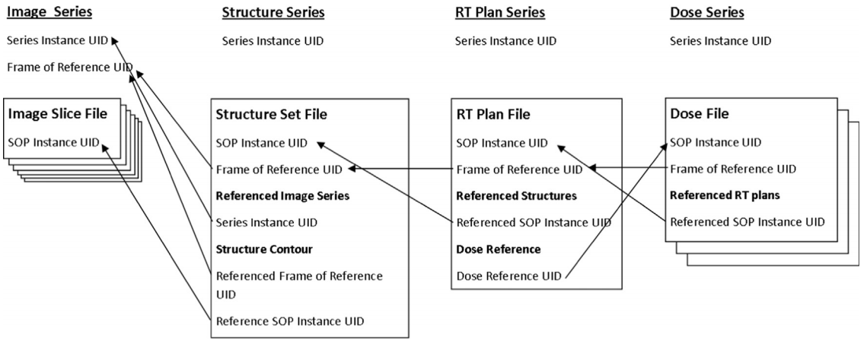

The figures have been generated using 3D Slicer (v4.8.1, Surgical Planning Laboratory, Harvard Medical School, Boston, MA, USA) [fedorov], and especially its RT module, SlicerRT from Queen’s University (Ontario, Canada) [pinter].

Patient information

The patient’s information has been designed as follows.

Family name NCS TPS QA
Given name PHANTOM
ID NCSTPSQA2020
Birth date 18/04/2018
Sex M
Institution name NCS

CT1

The first phantom is a CT of 280 slices of 512x512 voxels. The voxel size is 1x1x1 mm³. The origin is set at the center of the image. The ‘ImagePatientPosition’, which is the position of the center of the upper left voxel, is at (-255.5, -255.5, 139.5) mm for the first image.
Here is a summary of the relevant Dicom tags of this phantom.

Directory phantom1
Files CT1_xxx.dcm
Modality CT
Series description NCS TPS QA Phantom 1
Patient position HFS
Voxel size [mm³] 1 x 1 x 1
Image size [voxels] 512 x 512 x 280
Image 1 Patient position [mm] (-255.5, -255.5, 139.5)

Some structures have been set to a known Hounsfield unit as the background is set to -1000.

Position Dimensions HU Mimicking tissue
Cylinder Centered H = 240 mm and R = 200 mm 0 Water
Big cube Centered L= 200 mm -100 Fat
Cube 1 Centered L = 20 mm 40 Soft tissue
Cube 2 50 mm LEFT L = 20 mm 1800 Cortical bone
Cube 3 70 mm POST L = 20 mm 4000 Prosthesis
Cube 4 40 mm SUP L = 20 mm -700 Lung

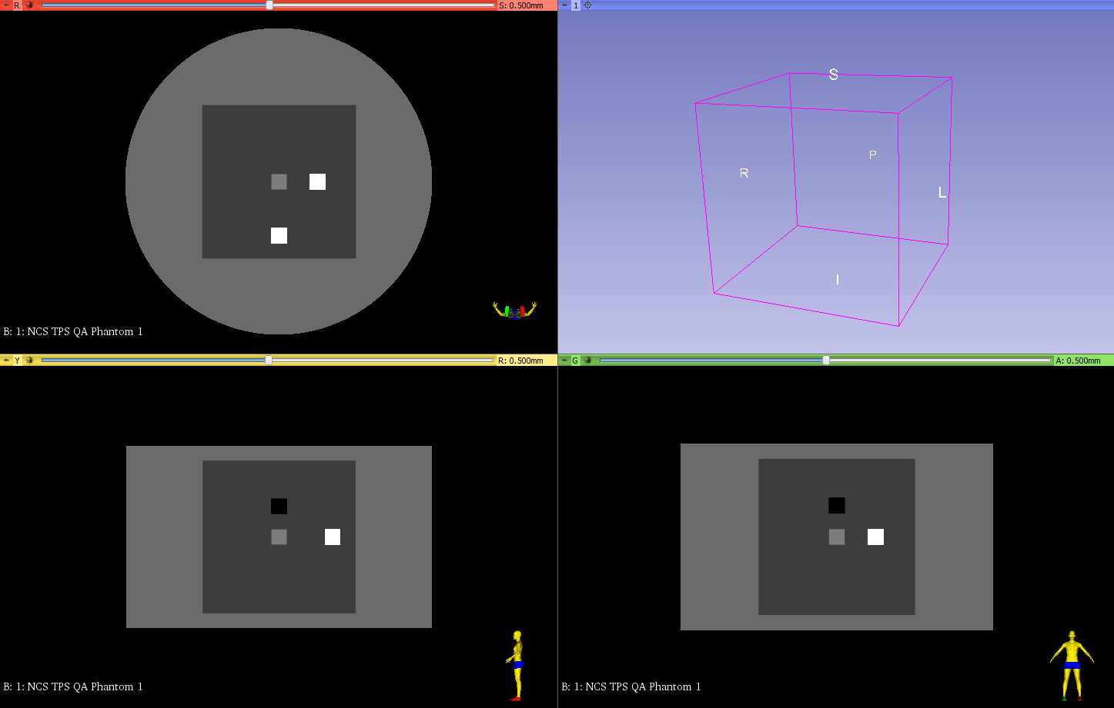

RTStruct

Directory phantom1
File RTSS1.dcm
Modality RTSTRUCT
Series description NCS TPS QA RTSS1
Structure set label RTSS1
Manufacturer model name WriteDICOMStructures

A RTStruct file has been generated for all the structures visible in CT1 on every slice. All structures have a geometric type set to ‘CLOSED_PLANAR’, a contour slab thickness of 1 mm and different Dicom interpreted types, as summarized in the following table.

# Name Type Slices (Top, Bottom) [mm] Points/slice Volume [cm³]
1 ProsthesisCube PTV 20 (9.5, -9.5) 40 8.0
2 FatCube ORGAN 200 (99.5, -99.5) 400 8000.0
3 LungCube GTV 20 (49.5, 30.5) 40 8.0
4 BoneCube PTV 20 (9.5, -9.5) 40 8.0
5 SoftCube AVOIDANCE 20 (9.5, -9.5) 40 8.0
6 WaterCylinder EXTERNAL 240 (119.5, -119.5) 201 30159.3

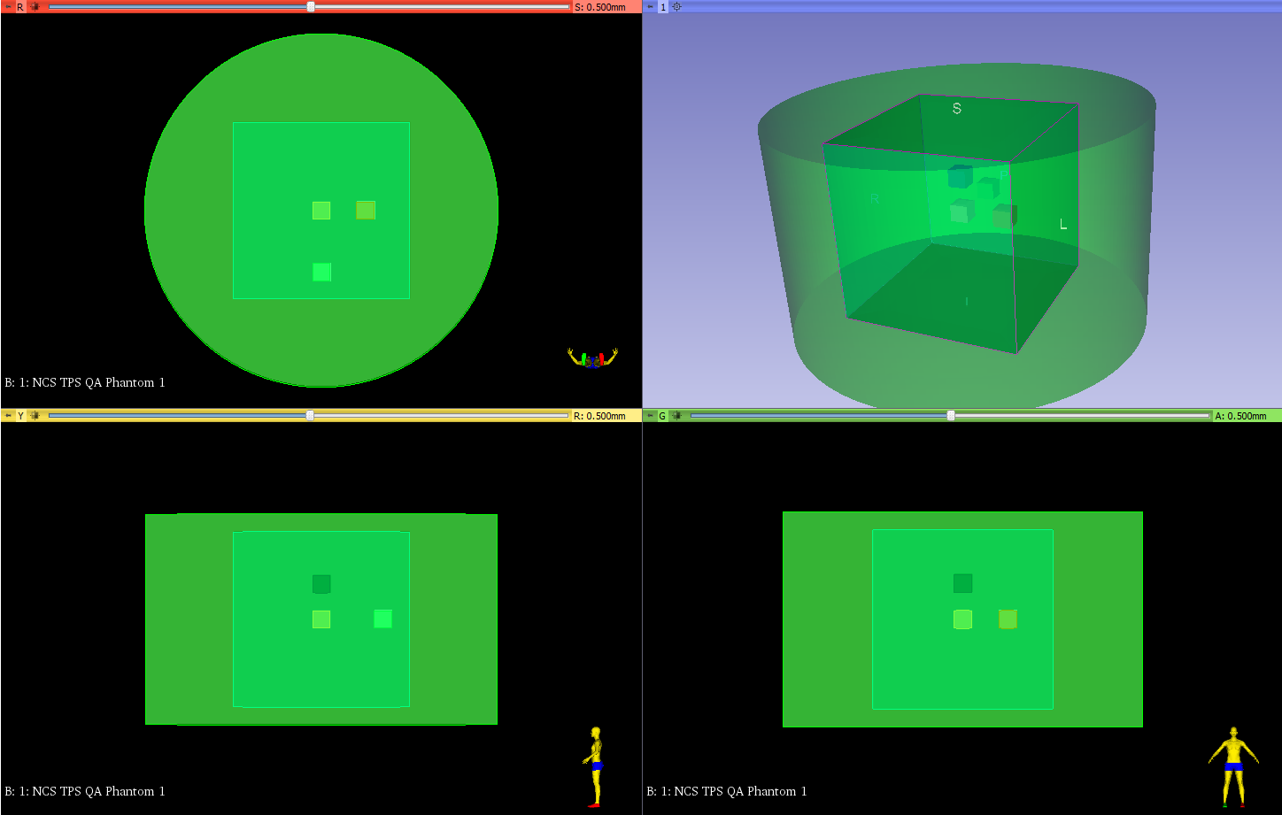

RTPlan and RTDose

Directory phantom1 phantom1
Files RTPlan1.dcm RTDose1.dcm
Modality RTPLAN RTDOSE
Series description NCS TPS QA RTPlan NCS TPS QA RTDose
Manufacturer model name WriteDICOMPlan WriteDICOMDose

The RTPlan is composed of 2 opposed static photon beams with open fields of 40x40 cm² for 5 fractions of treatment. Some relevant DICOM tags are summarized in the following table.

Beam name ant post
Beam type STATIC STATIC
Radiation type PHOTON PHOTON
Delivery type TREATMENT TREATMENT
Gantry angle [°] 0 180
Collimator angle [°] 0 180
Beam meterset [MU] 1644.4 1770.7
Dose rate [MU/min] 400 400

The RTDose has been designed to match exactly the matrix of the primary image (CT1). The dose grid size is 1x1x1 mm³ and the ‘ImagePositionPatient’, which is the position of the upper left voxel of the last slice in RTDose files, is (-255.5, -255.5, -139.5) mm. The units and type of dose are set to ‘GY’ and ‘PHYSICAL’ respectively. In this file, the structures have been set a uniform dose as illustrated in the table below.

Structure Dose [Gy]
BoneCube 25
ProsthesisCube 30
LungCube 35
SoftCube 40
FatCube 20
WaterCylinder 5

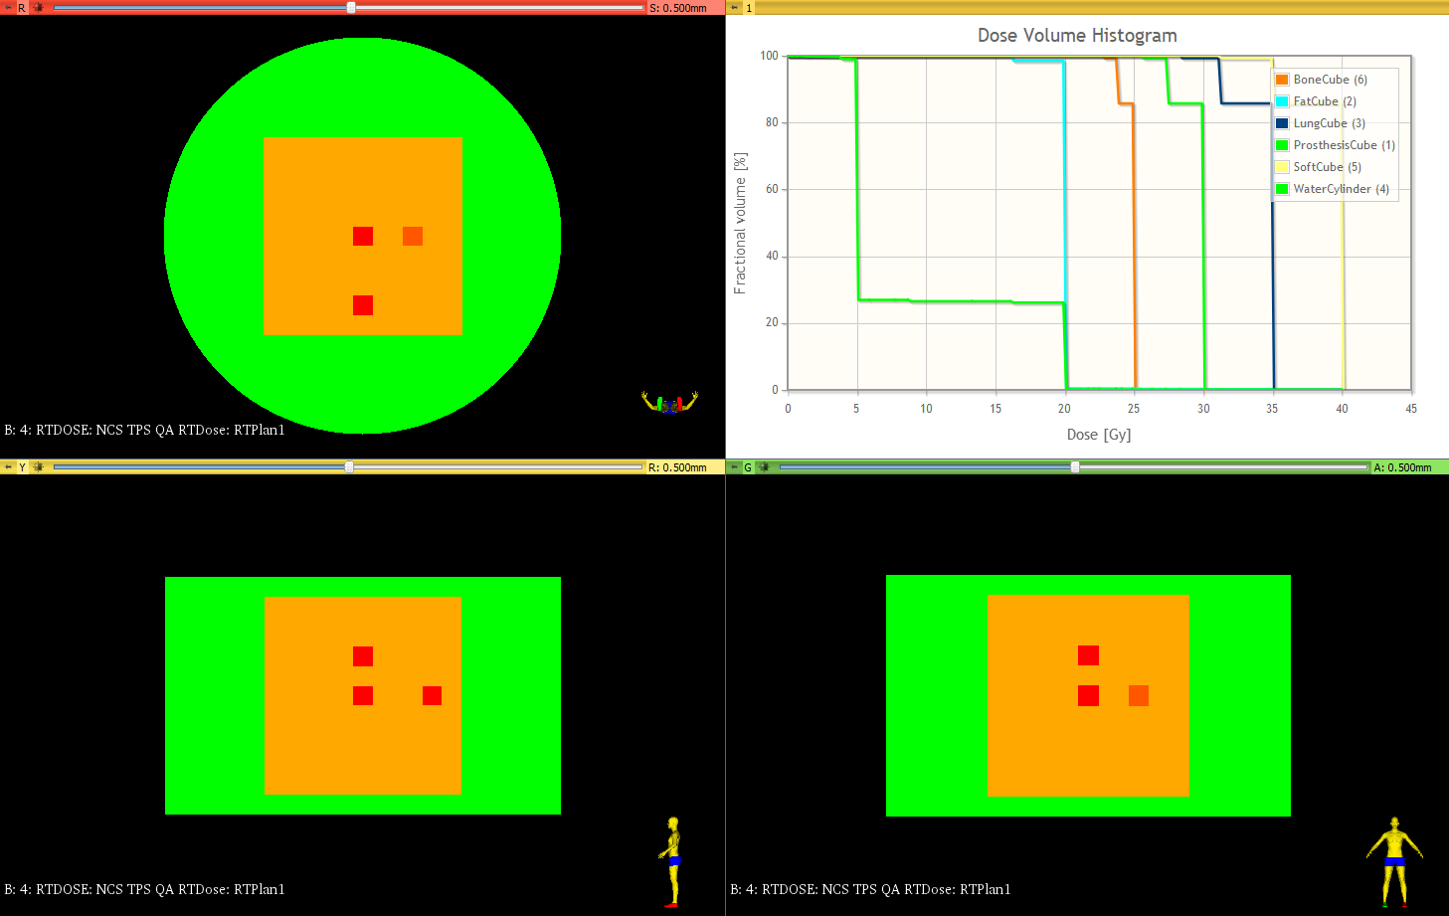

The dose volume histogram (DVH) does not seem to be perfectly displayed in this viewer. For the 4 little cubes - BoneCube, ProsthesisCube, LungCube and SoftCube - there should only be a perfect step at 25, 30, 35 and 40 Gy respectively, as represented in the following figure. As the FatCube and the WaterCylinder encompass other structures, their DVH should not be a perfect step-like curve. Some dose statistics are summarized in the following table.

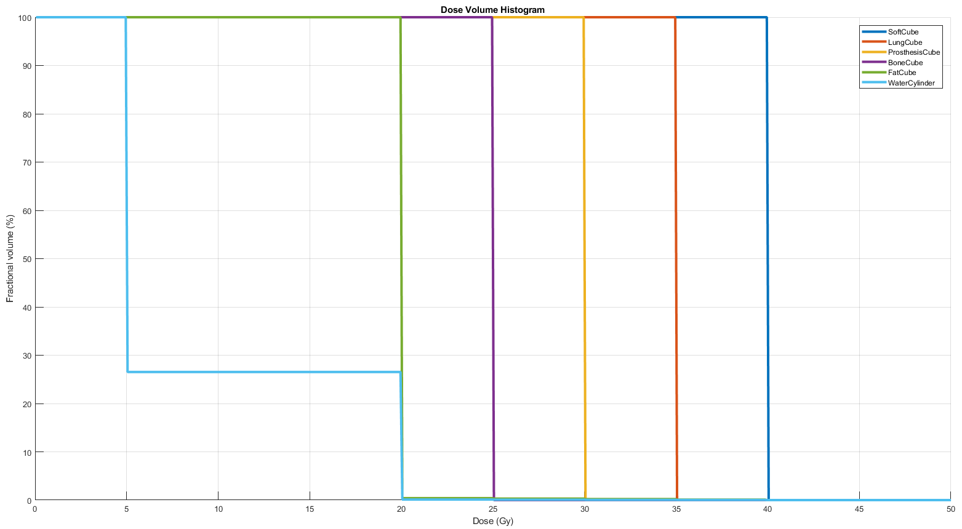

Structure Dmin [Gy] Dmax [Gy] Dmean [Gy]
BoneCube 25 25 25
ProsthesisCube 30 30 30
LungCube 35 35 35
SoftCube 40 40 40
FatCube 20 40 20.050
WaterCylinder 5 40 8.992

MRI

Directory phantom1MRT2
Files MRT2_xxx.dcm
Modality MR
Series description NCS TPS QA Phantom MR T2
Patient position HFS
Voxel size [mm³] 1 x 1 x 1
Image size [voxels] 512 x 512 x 280
Image 1 Patient position [mm] (-255.5, -255.5, 139.5)

An MR T2-like image has been created, using the same resolution and position as the CT1, on a 3T imager. Signal values have been assigned to the different structures but they do not reflect any physical properties.

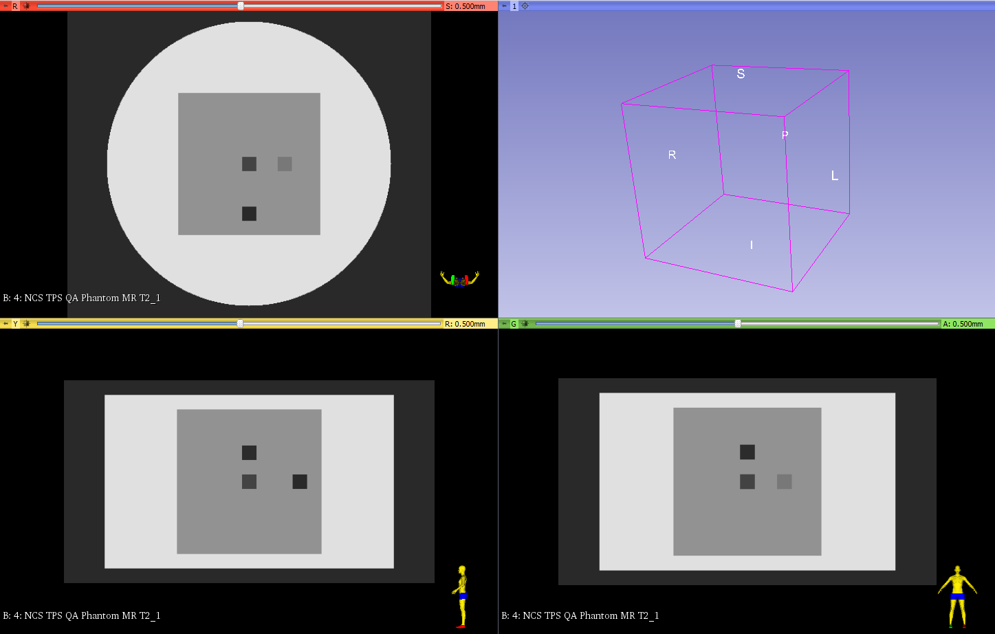

Structure Signal value
SoftCube 100
LungCube 10
BoneCube 300
ProsthesisCube 0
FatCube 400
WaterCylinder 700

PET

Directory phantom1PET
Files PET_xxx.dcm
Modality PT
Series description NCS TPS QA Phantom PET FDG
Study description 18F-FDG PET
Patient position HFS
Units BQML
Voxel size [mm³] 2.56 x 2.56 x 2.80
Image size [voxels] 200 x 200 x 100
Image 1 Patient position [mm] (-254.72, -254.72, 138.60)

An FDG PET-like image has been created, using first the same resolution and size as CT1 (1x1x1 mm³ and 512x512x280 voxels). Activities have been assigned to the different structures, as shown in the following table, with the background set to 0.

Structure Activity [Bq/ml]
SoftCube 24000
LungCube 8000
BoneCube 8000
ProsthesisCube 8000
FatCube 3000
WaterCylinder 500

The 3D matrix has then been resampled to 200x200x100 voxels, leading to a new voxel size of 2.56x2.56x2.80 mm³, but keeping the origin in the center of the phantom with a new ‘ImagePositionPatient’ set to (-254.72, -254.72, 138.60) mm.

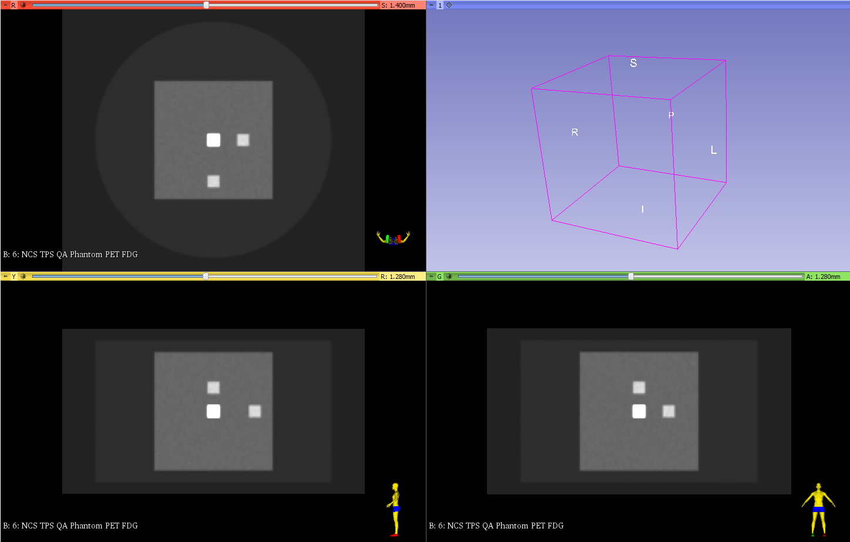

Patient position

New CTs have been generated based on CT1 to check for patient position and image orientation. The size and resolution were kept identical.

Directory phantom1FFS phantom1HFP phantom1FFP
Files CT1_FFS_xxx.dcm CT1_HFP_xxx.dcm CT1_FFP_xxx.dcm
Series Description NCS TPS QA Phantom 1 FFS … HFP … FFP
Patient position FFS HFP FFP
Image orientation [-1 0 0 ; 0 1 0] [-1 0 0 ; 0 -1 0] [1 0 0 ; 0 -1 0]

Shifts and tilts

Directory phantom1Shift
Files CT1_shift_xxx.dcm
Modality CT
Series Description NCS TPS QA Phantom 1 Shifted
Voxel size [mm³] 1 x 1 x 1
Image size [voxels] 512 x 512 x 280
Image 1 Patient position [mm] (-255.5, -255.5, 139.5)

A shifted CT has been created based on CT1. The size and the resolution are kept the same. Only the structures in the image were shifted according to the following table. The ‘ImagePositionPatient’ is kept at (-255.5, -255.5, 139.5) mm.

Shift [mm] Direction
AP 20 POST
LR 30 LEFT
SI 10 INF

A rigid registration Dicom file has also been created, bringing back the CT shifted to the space of CT1.

Directory phantom1Shift
File REG_shift.dcm
Modality REG
Series description NCS TPS QA REG shifts

The transformation matrix is naturally given by
$$\left(\begin{matrix}\begin{matrix}1 & 0 \\ 0 & 1\end{matrix} & \begin{matrix}0 & -30 \\ 0 & -20\end{matrix} \\ \begin{matrix}0 & 0 \\ 0 & 0\end{matrix} & \begin{matrix}1 & 10 \\ 0 & 1\end{matrix}\end{matrix}\right)$$
which is a translation vector of (-30, -20, 10) mm and a rotation vector of (0, 0, 0) °.

Directory phantom1Tilt phantom1MRtilt
Files CT1_tilt_xxx.dcm MRtilt_xxx.dcm
Modality CT MR
Series description NCS TPS QA Phantom 1 Tilted NCS TPS QA Phantom MR Tilted
Voxel size [mm³] 1 x 1 x 1 2 x 2 x 4
Image size [voxels] 512 x 512 x 280 256 x 256 x 70
Image 1 Patient position [mm] (-255.5, -349.0, 93.5) (-255.0, -347.8, 92.5)
Image n Patient position [mm] (-255.5, -209.5, -148.1) (-255.0, -209.8, -146.6)

A tilted CT has also been created based on CT1, and a tilted MRI as well. The CT kept its original resolution and size while it changed to 256x256x70 voxels and 2x2x4 mm³ for the MRI, without changing the origin of the images.
Both images have been tilted with an angle of 30° along the LR axis. The ‘ImagePositionPatient’ should also vary, not only through its slice location, but taking tilt into account as well.

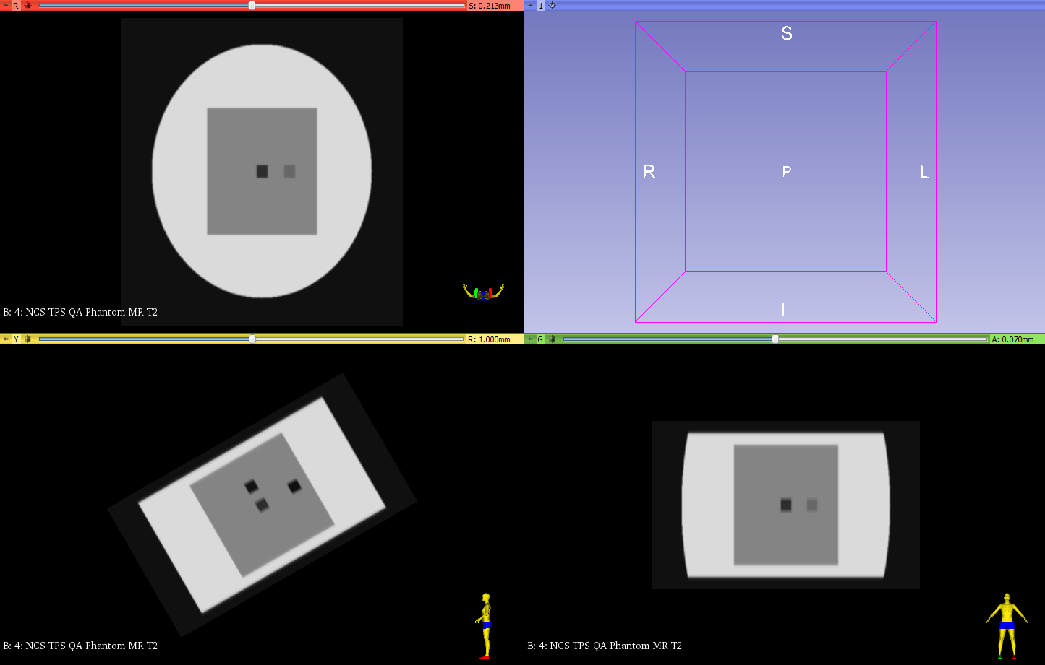

A rigid registration Dicom file has also been created, bringing back the CT tilted to the space of CT1.

Directory phantom1Tilt
File REG_tilt.dcm
Modality REG
Series description NCS TPS QA REG tilt

The transformation matrix is naturally given by
$$\left(\begin{matrix}\begin{matrix}1 & 0 \\ 0 & 0.87\end{matrix} & \begin{matrix}0 & 0 \\ 0.50 & 0\end{matrix} \\ \begin{matrix}0 & -0.50 \\ 0 & 0\end{matrix} & \begin{matrix}0.87 & 0 \\ 0 & 1\end{matrix}\end{matrix}\right)$$
which is a translation vector of (0, 0, 0) mm and a rotation vector of (-30, 0, 0) °.

Dose grid

Other RTPlans and RTDoses were created to test for the dose grid effect. The RTPlans have the same configuration as the original RTPlan.

Directory phantom1rt2 phantom1rt3
Files RTPlan2_3mm.dcm RTPlan3_1mm.dcm
Modality RTPLAN RTPLAN
Series description NCS TPS QA RTPlan2 3mm NCS TPS QA RTPlan3 1mm

The original RTDose has been designed to match exactly the matrix of the primary image (CT1). The dose grid size is 1x1x1 mm³ and the ‘ImagePositionPatient’, which is the position of the upper left voxel of the last slice in RTDose files, is (-255.5, -255.5, -139.5) mm. The units and type of dose are set to ‘GY’ and ‘PHYSICAL’ respectively. In this file, the doses in the structures have been set to produce the following DVH.

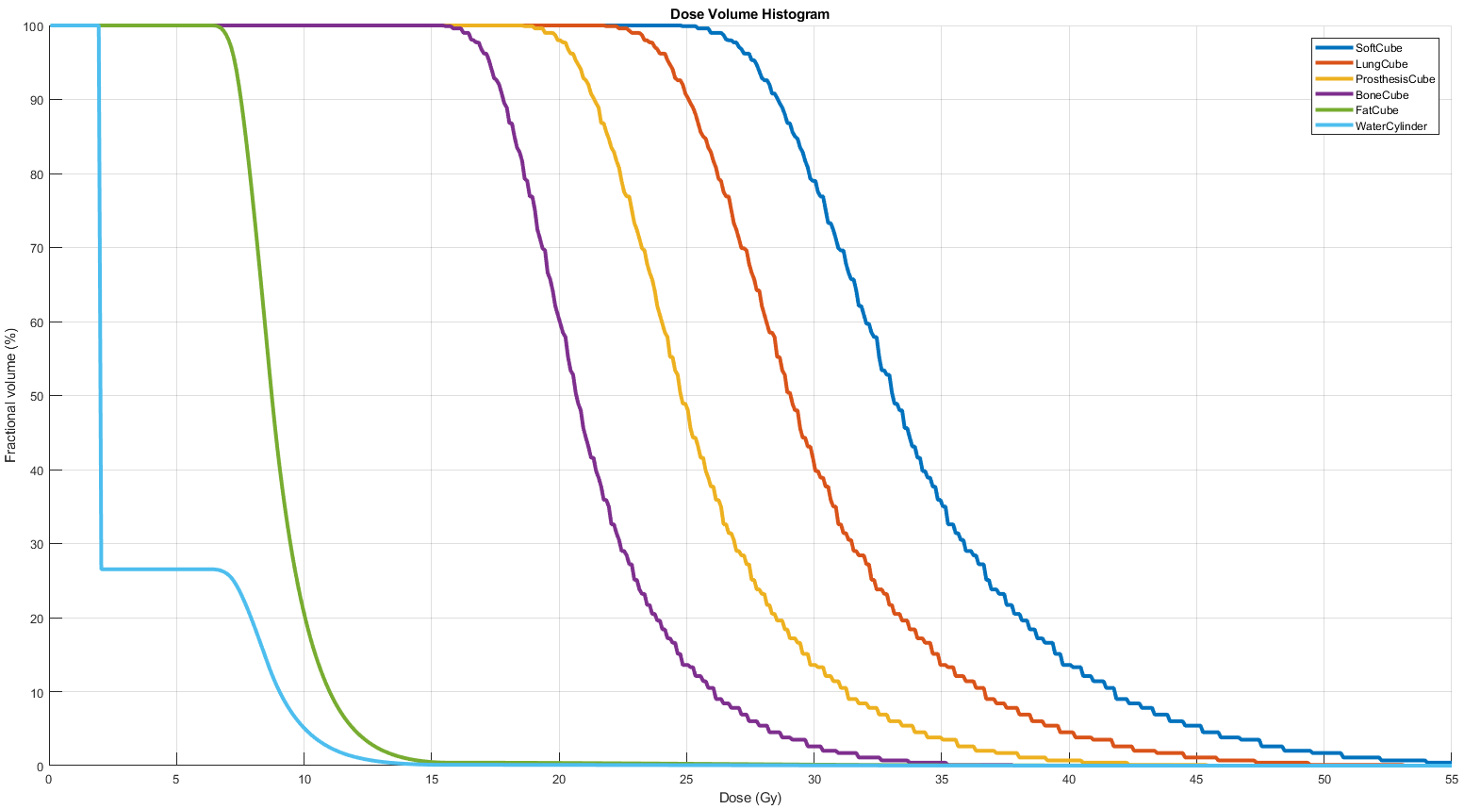

This original RTDose was first resized to a 170x170x92 voxels matrix with a dose grid of 3x3x3 mm³, leading to the RTDose2_3mm file. This dose was then super-sampled to a 510x510x276 voxels matrix with a dose grid of 1x1x1 mm³, the RTDose3_1mm file.

Directory phantom1rt2 phantom1rt3
Files RTDose2_3mm.dcm RTDose3_1mm.dcm
Modality RTDOSE RTDOSE
Series description NCS TPS QA RTDose2 3mm NCS TPS QA RTDose3 1mm
Voxel size [mm³] 3 x 3 x 3 1 x 1 x 1
Image size [voxels] 170 x 170 x 92 510 x 510 x 276
Image Patient Position [mm] (-253.5, -253.5, -136.5) (-254.5, -254.5, -137.5)

This new dose distribution produces a DVH as illustrated in the following figure. Some dose statistics are summarized in the following table.

Doses (Gy) Min Max Mean D1% D5% D20% D50% D80% D95% D99%
SoftCube 14.89 50.40 31.29 16.02 18.85 20.40 32.88 36.64 43.31 50.40
LungCube 11.80 44.61 27.23 13.12 16.11 17.74 28.48 32.77 37.13 44.61
ProsthesisCube 10.04 38.48 23.33 11.30 13.42 16.34 24.15 28.63 32.79 38.48
BoneCube 11.17 32.28 20.03 12.25 13.10 16.21 19.96 23.43 27.42 32.28
FatCube 2.02 50.40 8.83 2.42 6.59 7.69 8.65 9.96 11.87 13.97
WaterCylinder 0.05 50.40 3.78 0.86 1.83 2.00 2.00 7.85 10.04 12.26
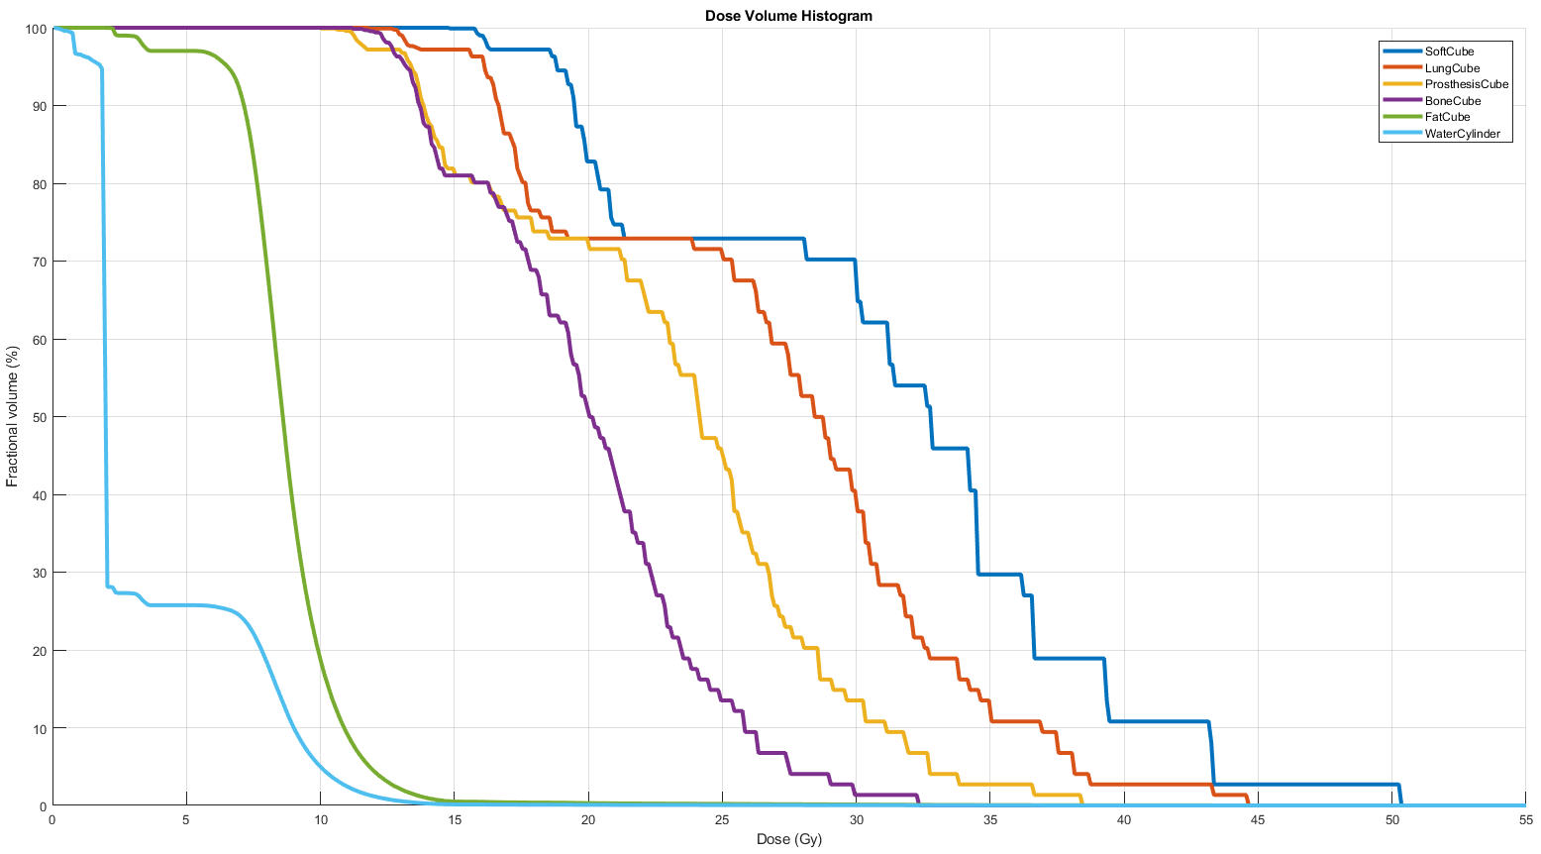

CT2

Another phantom has been designed to test for structure expansion and shrinkage. This phantom is a CT of 300 slices of 512x512 voxels. The voxel size is 1x1x1 mm³. The origin is set at the center of the image. The ‘ImagePatientPosition’ is at (-255.5, -255.5, 149.5) mm for the first image.

Directory phantom2
Files CT2_xxx.dcm
Modality CT
Series description NCS TPS QA Phantom 2
Patient position HFS
Voxel size [mm³] 1 x 1 x 1
Image size [voxels] 512 x 512 x 300
Image 1 Patient position [mm] (-255.5, -255.5, 149.5)

The diabolo structures have been designed following the instructions of the NCS report 15 [ncs15] and are recalled here.

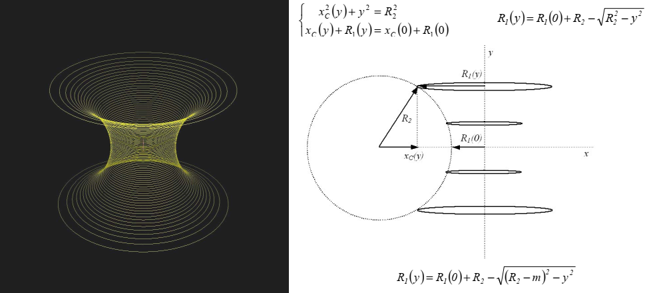

The different structures are centered and have been set to a known Hounsfield unit as the background is set to -1000.

Dimensions (mm) Volume (cm³) HU Mimicking tissue
Cylinder H = 280, R = 200 35175.6 0 Water
Diabolo1 R1(0) = 40, R2 = 150, m = 0 1777.0 40 Soft tissue
Diabolo+ R1(0) = 40, R2 = 150, m = 10 3188.1 -700 Lung
Diabolo- R1(0) = 40, R2 = 150, m = -5 1281.6 1800 Cortical bone

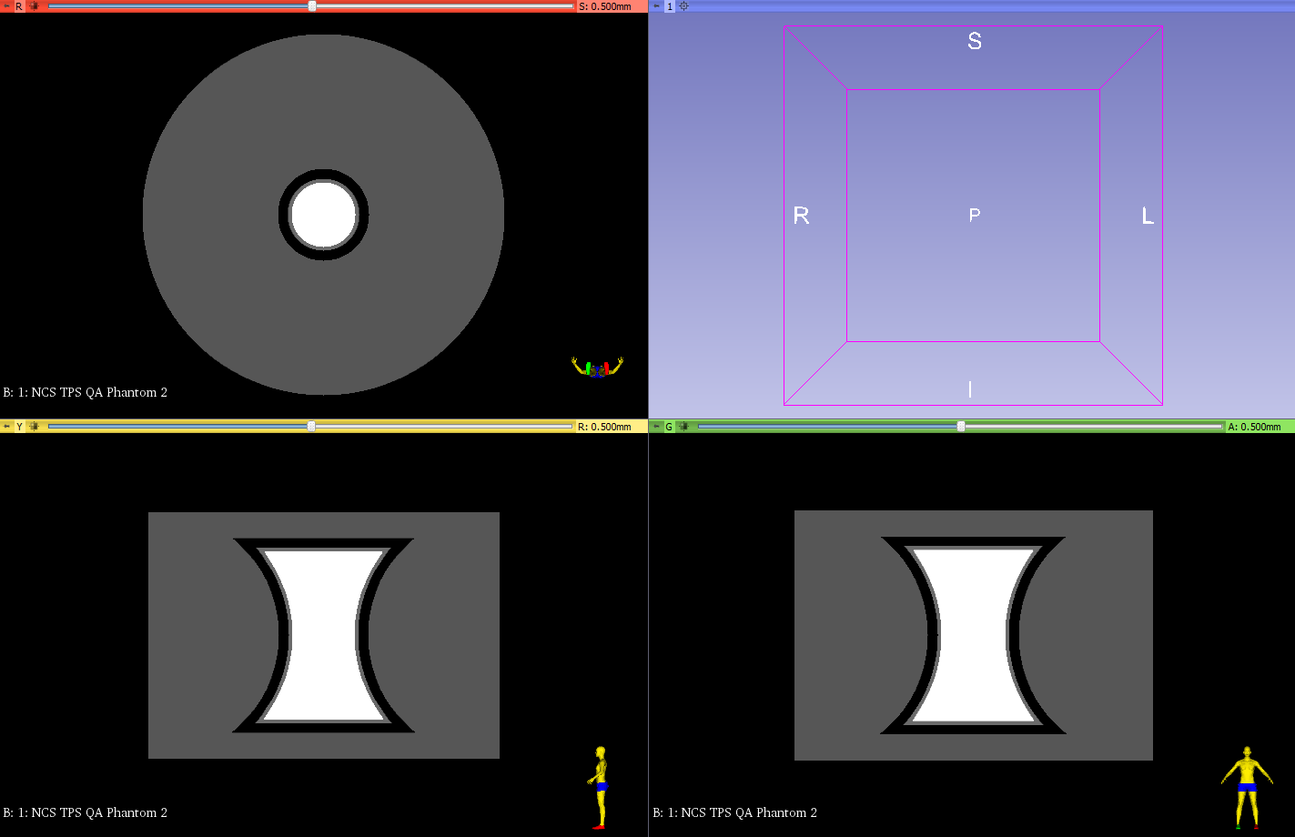

References

[geurts] Geurts M. DICOM Manipulation Tools. 2018, GitHub Repository, University of Wisconsin, Madison, WI, USA, https://github.com/mwgeurts/dicom_tools

[newhauser] Newhauser W, Jones T, Swerdloff S, Newhauser W, Cilia M, Carver R, Halloran A, Zhang R. Anonymization of DICOM electronic medical records for radiation therapy. 2014, Computers in Biology and Medicine 53: 134-140

[fedorov] Fedorov A, Beichel R, Kalpathy-Cramer J, Finet J, Fillion-Robin J-C, Pujol S, Bauer C, Jennings D, Fennessy FM, Sonka M, Buatti J, Aylward SR, Miller JV, Pieper S, Kikinis R. 3D Slicer as an Image Computing Platform for the Quantitative Imaging Network. 2012, Magnetic Resonance Imaging 30(9):1323-1341

[pinter] Pinter C, Lasso A, Wang A, Jaffray D, Fichtinger G. SlicerRT – Radiation therapy research toolkit for 3D Slicer. 2012, Medical Physics 39(10):6332-6338

[ncs15] Bruinvis IAD, Keus RB, Lenglet WJM, Meijer GJ, Mijnheer BJ, van ‘t Veld AA, Venselaar JLM, Welleweerd J, Woudstra E. Quality assurance of 3-D treatment planning systems for external photon and electron beams. Report 15 of the Netherlands Commission on Radiation Dosimetry. 2005

